2nd step Create feedforward NN and train, test, data set

When I created the merged data set files in step 01 and next step need to be a crated feedforward NN and train data set and testing dataset and get their training and testing accuracy.

First need to load the meagre data file before creating that file in 1st step. Then doing normalization dataset and need defined the neural network and hidden layer size, and feedforward NN like Levenberg-Marquardt as the training algorithm. Then Divide data into training, validation, and test sets and Set training parameters. After training the neural network needs to check intra and inter variance value and calculate the training features and sample. When I used the loop, I checked the variance values and displayed the variance results. Then get the tarin accuracy test accuracy and finally save the result in trained_results.mat file.

The code is given below.

% Load the merged dataset

load('mergedData.mat');

% The merged data should be in the variable `merged_data`.

% Separate features and targets(labels)

% Assuming the last column is the user identifier (target/labels)

% And other all columns correspond to the Features

inputs = merged_data(:, 1:end-1)'; % Features (transpose to match NN input format)

targets = merged_data(:, end)'; % User identifiers(targets/labels) (transpose for NN format)

% Normalize the input data (optional, improves NN performance)

inputs = normalize(inputs, 'range'); % Define Normalize to [0, 1] range

% Create and configure the neural network

hiddenLayerSize = [20,10]; % Define the size of the hidden layer

net = feedforwardnet(hiddenLayerSize, 'trainlm'); % Feedforward NN with Levenberg-Marquardt as the training algorithm

% Divide data into training, validation, and test sets

net.divideParam.trainRatio = 0.7; % 70% training

net.divideParam.valRatio = 0.15; % 15% validation

net.divideParam.testRatio = 0.15; % 15% testing

% Set training parameters (optional, can tweak to improve performance)

net.trainParam.epochs = 1000; % Maximum number of training iterations

net.trainParam.goal = 1e-6; % Performance goal (MSE)

net.trainParam.min_grad = 1e-7; % Minimum gradient

% Train the neural network

[net, tr] = train(net, inputs, targets);

% Evaluate intra-variance and inter-variance for the training set

% Extract training set inputs and targets

train_inputs = inputs(:, tr.trainInd); % Features of training set

train_targets = targets(tr.trainInd); % Targets of training set

% Get unique classes in the training set

unique_classes = unique(train_targets);

% Initialize intra-variance and inter-variance

intra_variance = 0;

inter_variance = 0;

% Calculate overall mean of the training features

overall_mean = mean(train_inputs, 2); % Overall mean across all features (column-wise)

% Total number of samples in the training set

total_samples = size(train_inputs, 2);

% use loop calculate variance metrics for each class

for i = 1:length(unique_classes)

% Find the indices of samples belonging to the current class

class_idx = find(train_targets == unique_classes(i));

% Extract features of the current class

class_samples = train_inputs(:, class_idx);

% Number of samples in this class

num_samples_in_class = size(class_samples, 2);

% Calculate the mean of the current class

class_mean = mean(class_samples, 2); % Mean across features for this class

% Compute intra-variance (variance within the class)

intra_variance = intra_variance + ...

sum(sum((class_samples - class_mean).^2)) / total_samples;

% Compute inter-variance (variance of class means relative to the overall mean)

inter_variance = inter_variance + ...

num_samples_in_class * sum((class_mean - overall_mean).^2) / total_samples;

end

% Display inter and intra variance results

fprintf('Intra-variance (Training Set): %.4f\n', intra_variance);

fprintf('Inter-variance (Training Set): %.4f\n', inter_variance);

% Evaluate training accuracy for the training set

train_outputs = net(inputs(:, tr.trainInd)); % Network predictions for training set

train_predicted_classes = round(train_outputs); % Round predictions to nearest integer

train_actual_classes = targets(tr.trainInd); % Actual training targets

% Calculate training accuracy

train_correct_predictions = sum(train_predicted_classes == train_actual_classes);

train_total_samples = length(train_actual_classes);

train_accuracy = (train_correct_predictions / train_total_samples) * 100;

fprintf('Training Accuracy: %.2f%%\n', train_accuracy);

% Evaluate test accuracy

test_inputs = inputs(:, tr.testInd); % Inputs for the test set

test_targets = targets(tr.testInd); % Targets for the test set

% Generate predictions for the test set

test_outputs = net(test_inputs);

test_predicted_classes = round(test_outputs);

test_actual_classes = test_targets;

% Ensure classes are positive integers starting from 1

% Shift classes to be 1-based if they start at 0 or contain negative values

min_class = min([test_actual_classes, test_predicted_classes]);

if min_class <= 0

test_actual_classes = test_actual_classes - min_class + 1;

test_predicted_classes = test_predicted_classes - min_class + 1;

end

% Calculate test accuracy

test_correct_predictions = sum(test_predicted_classes == test_actual_classes);

test_total_samples = length(test_actual_classes);

test_accuracy = (test_correct_predictions / test_total_samples) * 100;

fprintf('Test Set Accuracy: %.2f%%\n', test_accuracy);

% Plot performance and confusion matrix

figure;

plotperform(tr); % Performance plot (training, validation, test errors)

% One-hot encode the test targets and predicted classes for confusion matrix

num_classes = max([test_actual_classes, test_predicted_classes]); % Determine the number of unique classes

test_actual_classes_onehot = ind2vec(test_actual_classes, num_classes); % One-hot encode actual classes

test_predicted_classes_onehot = ind2vec(test_predicted_classes, num_classes); % One-hot encode predicted classes

% Plot confusion matrix using one-hot encoded labels

figure;

plotconfusion(test_actual_classes_onehot, test_predicted_classes_onehot); % Confusion matrix

% Save the trained results and model

results.train_accuracy = train_accuracy; % Training accuracy

results.test_accuracy = test_accuracy; % Test accuracy

results.intra_variance = intra_variance; % Intra-variance

results.inter_variance = inter_variance; % Inter-variance

results.net = net; % Trained neural network

results.training_record = tr; % Training record (training, validation, test performance)

save('trained_results.mat', 'results'); % Save results

fprintf('Training results saved to "trained_results.mat".\n');

The code will shows the that result in command window

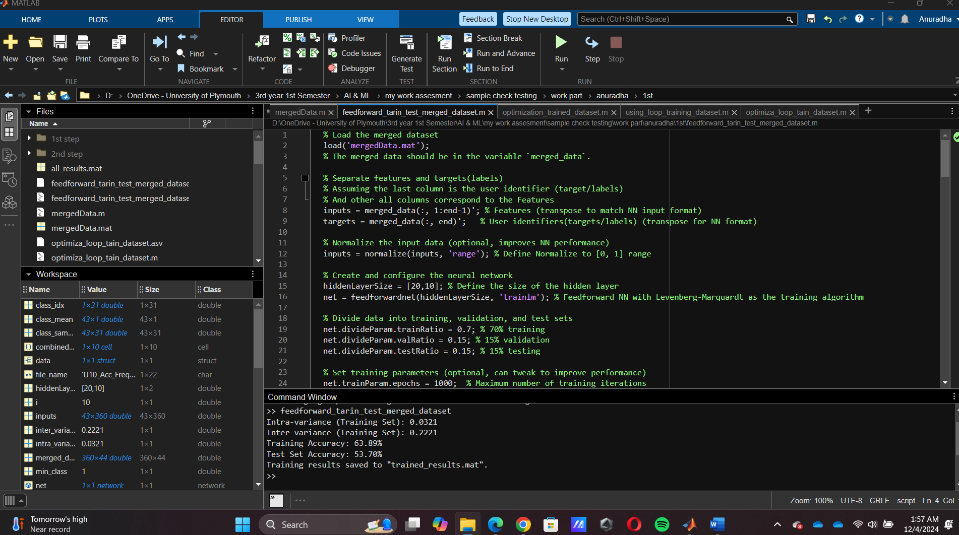

In that code it run while it gives tarin result like the popup and it provide confusion matrix graph and NN charts.

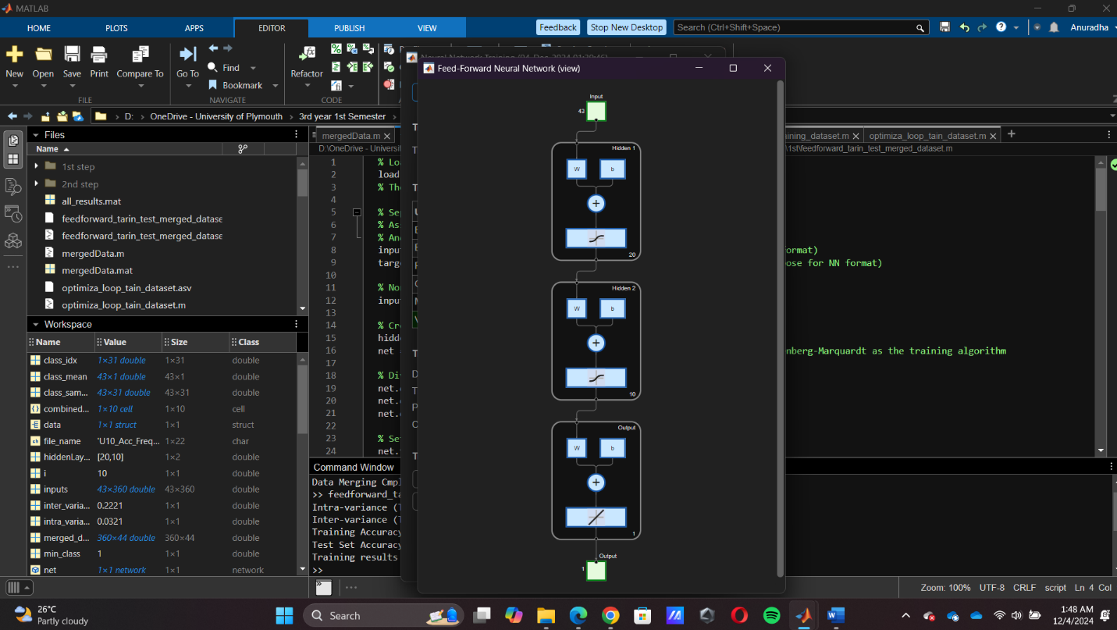When I used 2 hidden layers and defined 20 and 10 neurons in feedforward neural networks

